CSD-4464 Programming Java EE

WEEK 8

Assignment 4

Date: 18th March 2022

Output

Group E Members:

Anirudh Vallampatla C0796429

Meghana Kondaveeti C0784302

Srikanth Ajith Kumar Yarram C0793406

Vishal Kumar C0793379

Yamini Rathod C0796390

Edit Publisher, changed Name

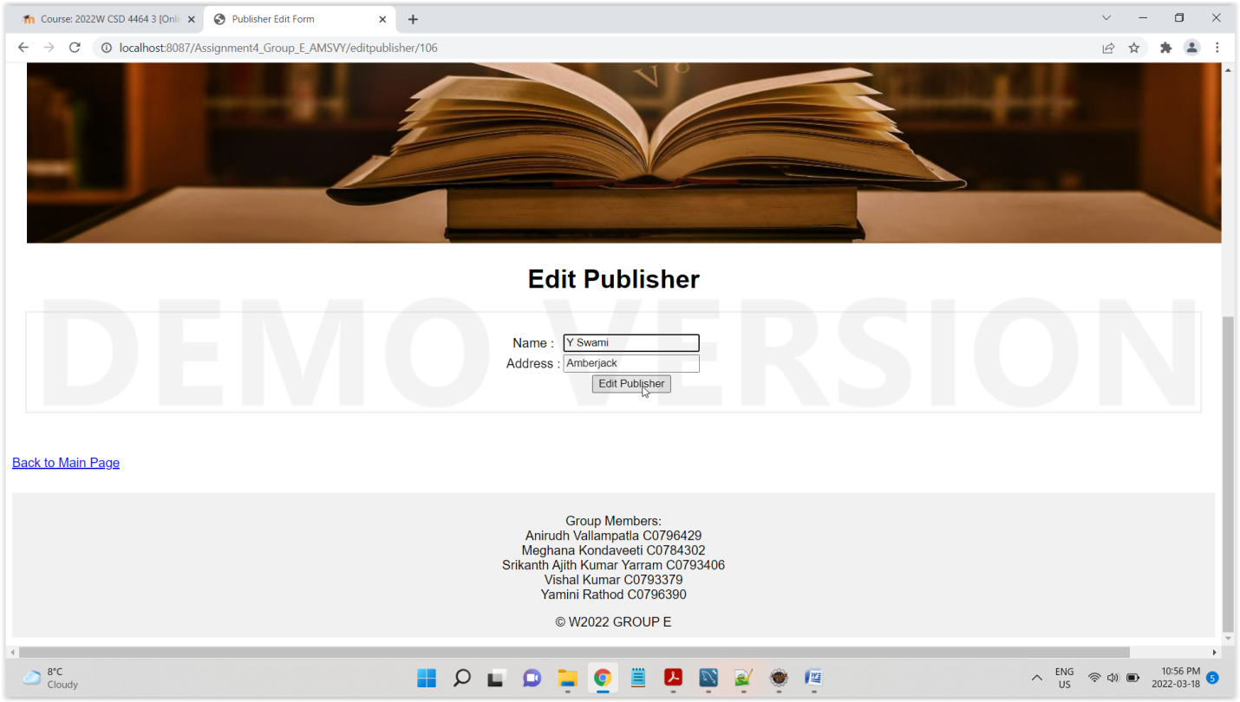

Publisher Edited

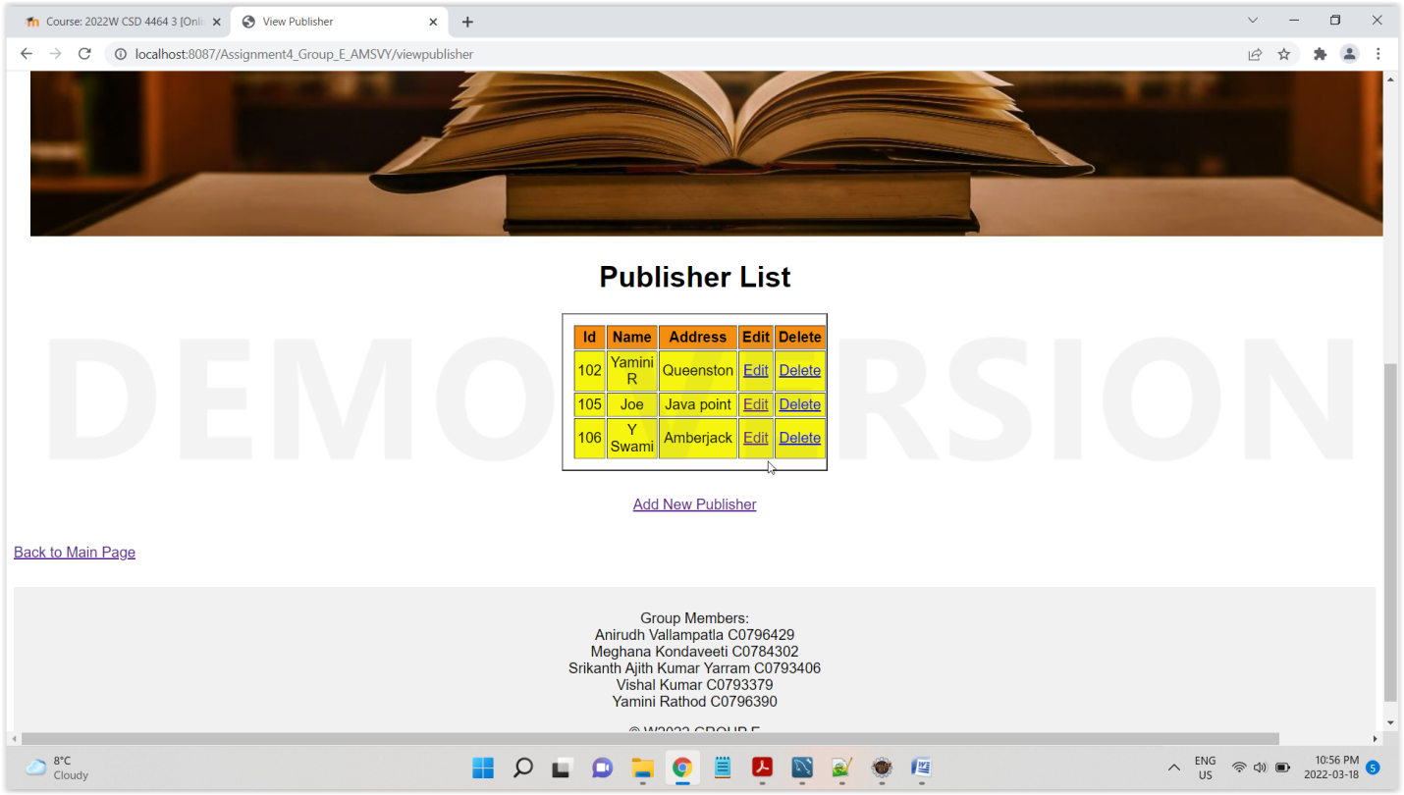

Delete Publisher

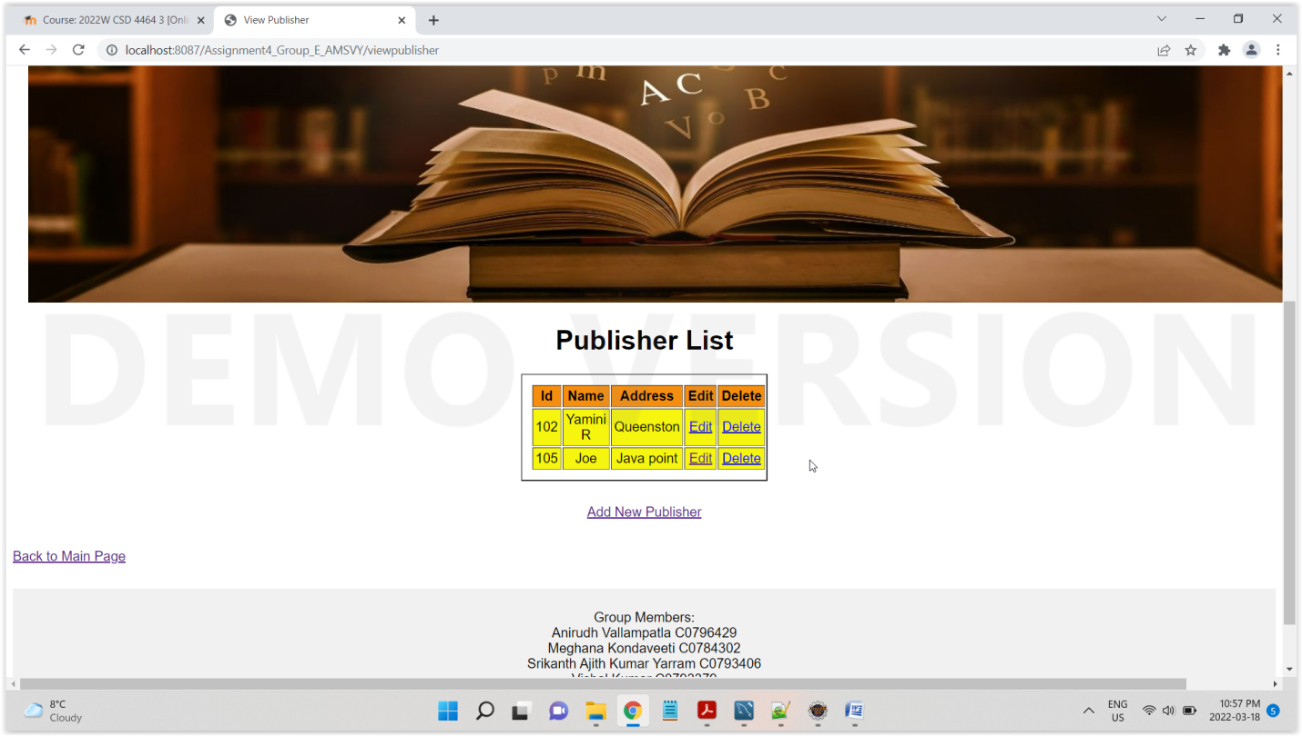

Add Book

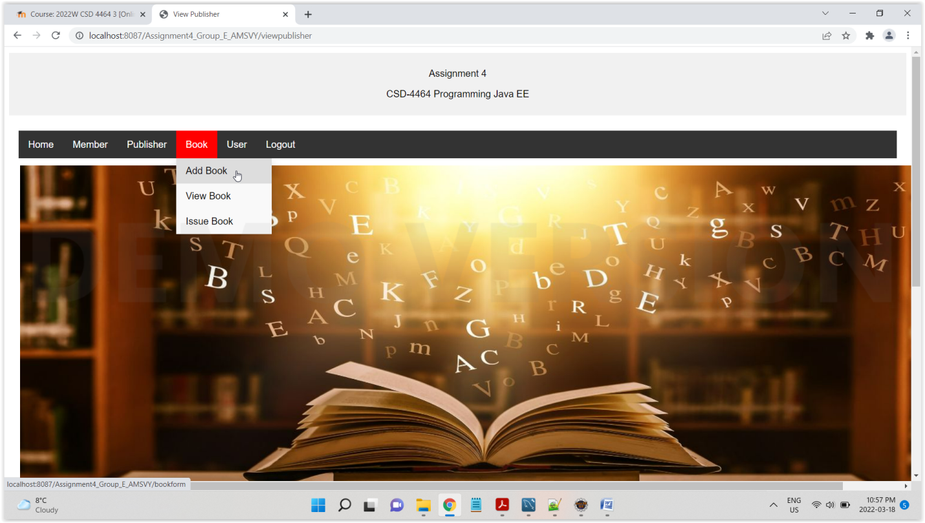

Adding Book (Notes: Tables are connected using referential Integrity, i.e. FK and PK. Application would throw an error if constraint rules are not followed, I am adding publisher id as 105 because it exists in publisher table, if we add any other values which does not exist in publisher table, then it would throw an error)

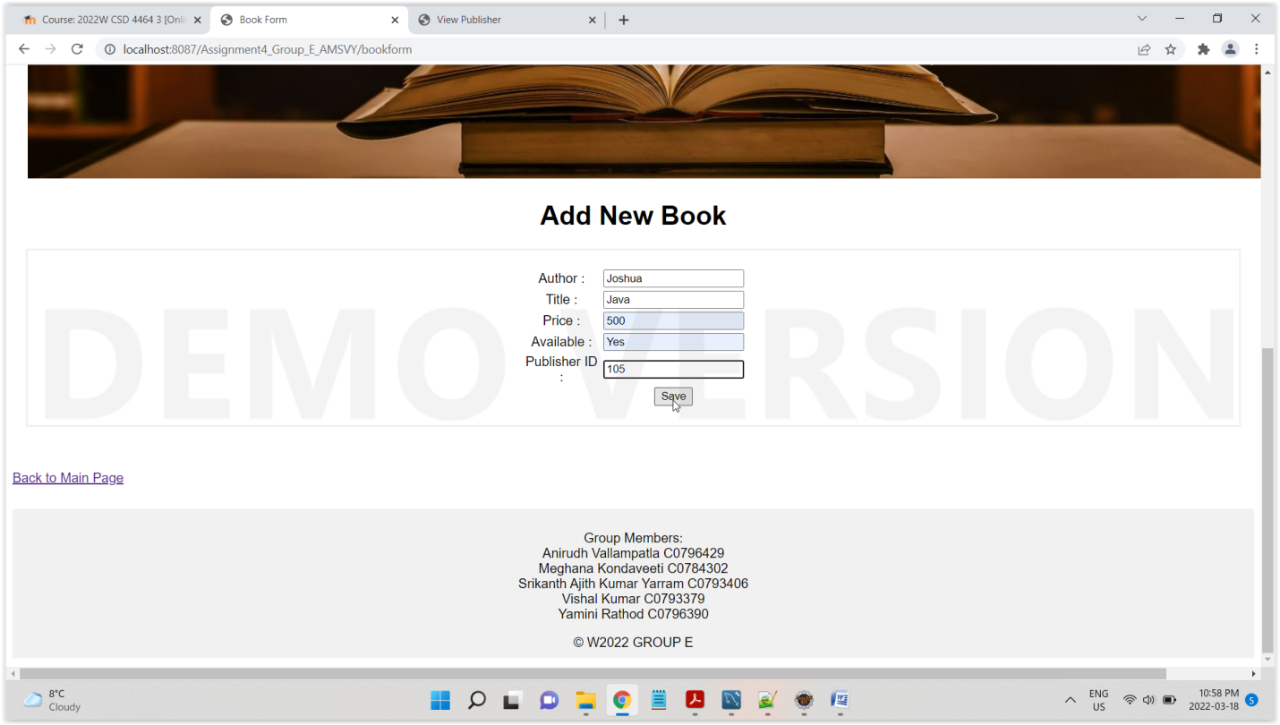

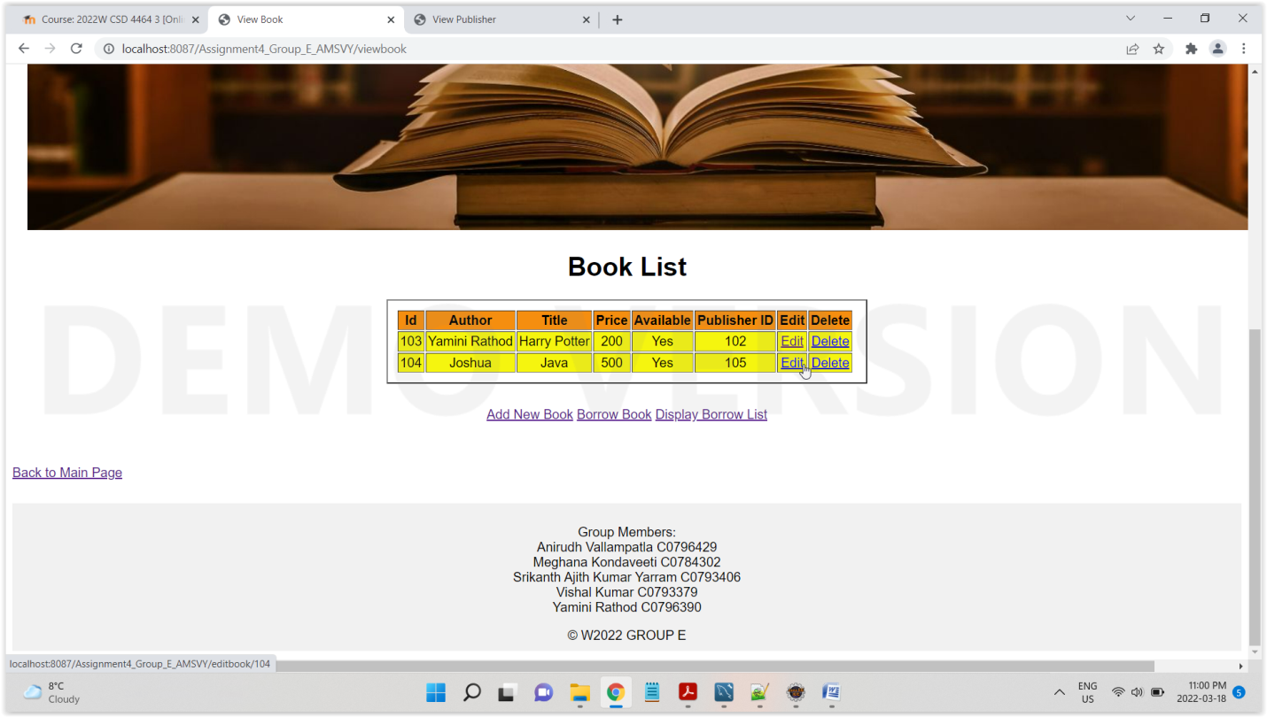

Edit book and try to change publisher id that does not exist in publisher table

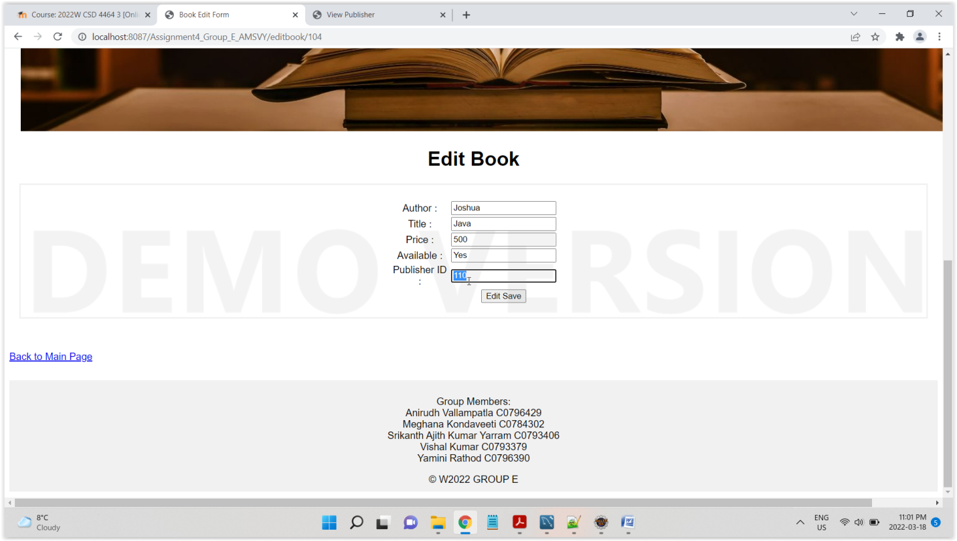

Referential Integrity Followed

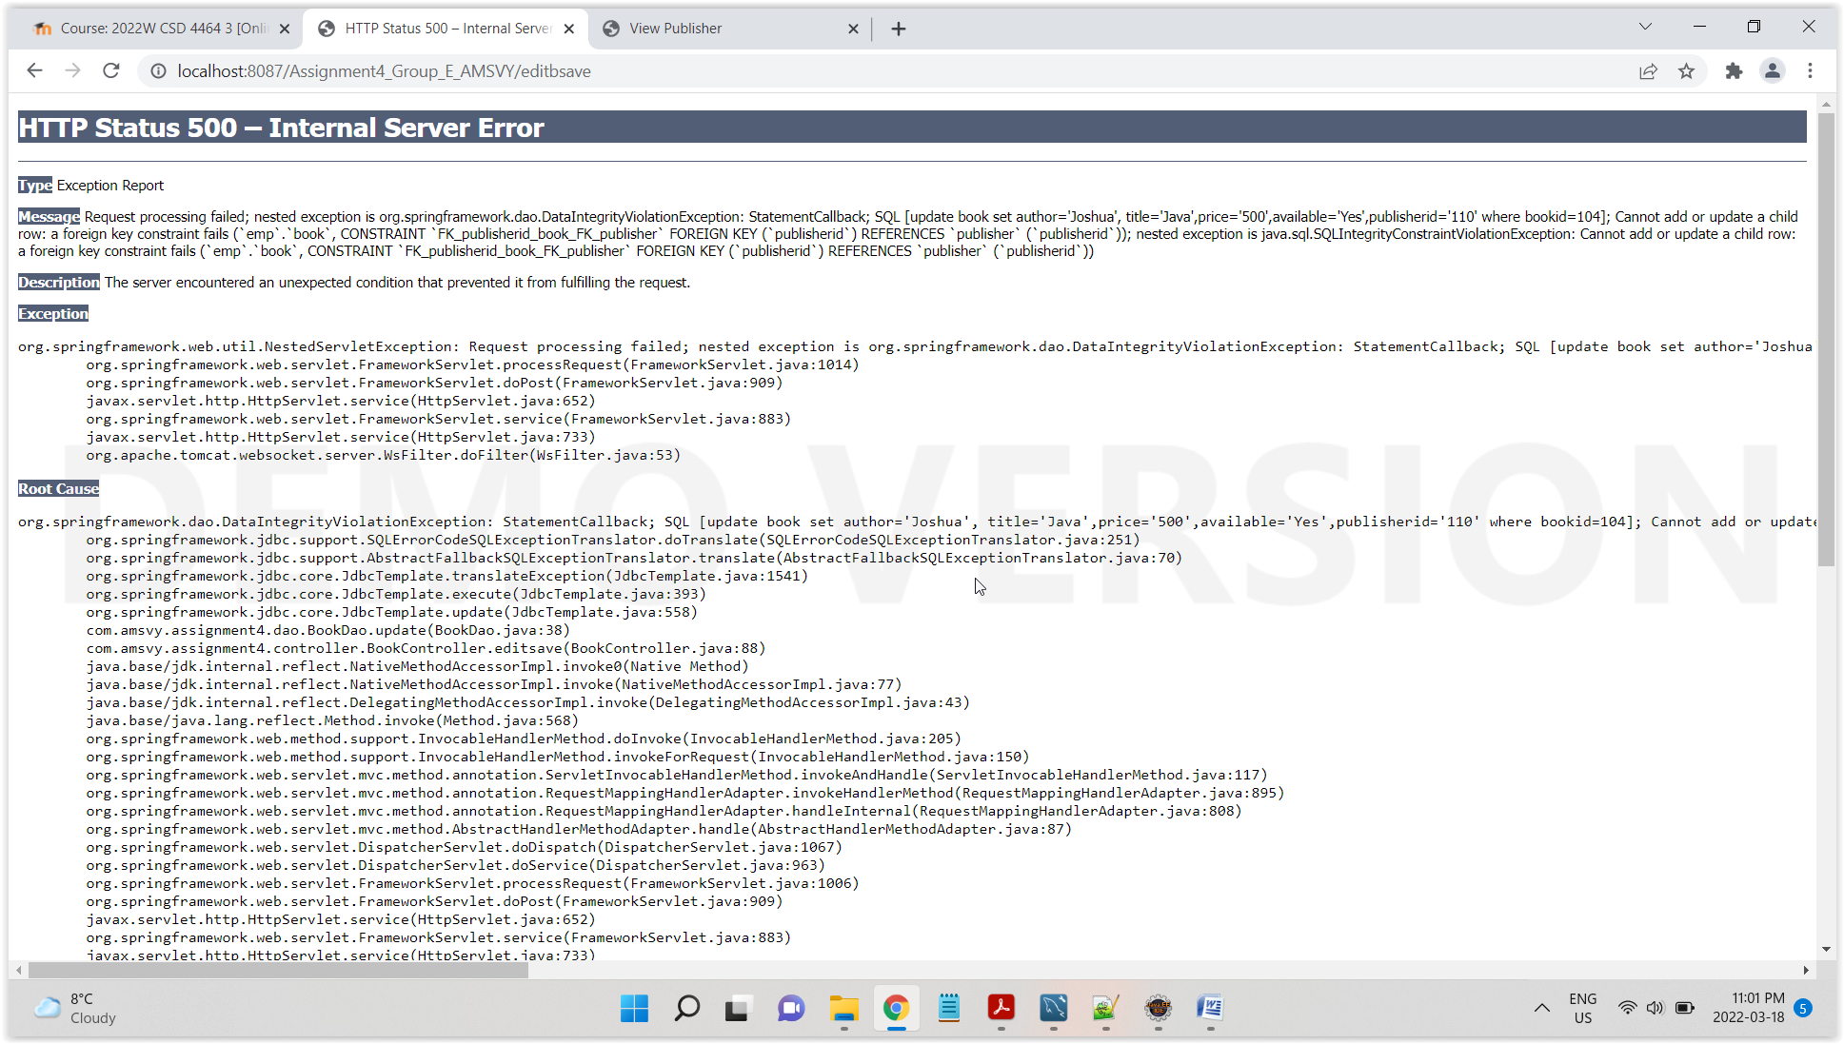

Edit with accurate data, changing price of book

